🥁 JHS Band & Orchestra Boosters
Monthly Meeting Agenda
Date: Tuesday, November 18, 2025
Time: 7:00 PM
Location: Skype

1. Call to Order (7:00 PM) (Dawn)
- Welcome/Introduction

2. Board Update (Dawn)
- Brief note about secretary transition
- Temporary plan for taking minutes
- Call for volunteers/nominations
- Vote in Susan as VP if everyone agrees

3. Director’s Report (Mr. Baker)
- Upcoming events, the Boosters may be needed for:
  - Parades?
  - Band performances?
- Any immediate needs from Band/Orchestra directors?

4. Treasurer’s Report (Denise)
- Current balance (if known)
- Recent expenses (if known)
- Outstanding vendor payments (if known)

5. Fundraising (Dawn & Susan)
Current:
- Donation Drive Progress for Slice the Price Fundraiser
Upcoming:
- Wicked 2 Movie Fundraiser (Meet the week of the 7th to finalize everything)
  - Does anyone have donations we can raffle off, decoration ideas, and/or other fun ways we can promote this event?
  - NOTE: Food cannot be brought into the theater, so I was planning to buy several large popcorns and sodas (Sprite or something kid friendly) and split them up in Wicked cups I am donating. Any other ideas?
- Holiday ideas /Candy Grams?
- Sponsorship outreach updates
  - Harco Signs - $10 single sided, $12 double sided (approximately 3 days to make)
  - Any others yet?

6. Events & Logistics (Dawn)
- Booster table for the school play (Thu/Fri/Sat)
  - 5:45 PM arrival Thu/Fri and 1PM arrival Sat
  - Will be selling Dominos cards
  - Will be selling Wicked Tickets
  - Will be raffling off a Clue Movie Basket each night ($1 a ticket or 6 for $5) NOTE: (Mr. Baker, can we offer school pickup to the winners and have them contact you for a convenient time or leave them in the office?) NOTE: (Denise, is there a process for cash donations to be given to you?)
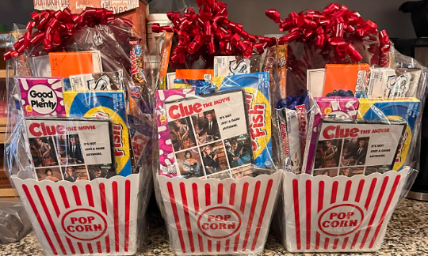
  - Will be encouraging people to join the Boosters & Donate
- Volunteer shifts (Before and After Play)
  - People should start to arrive by 6:30 PM
  - Susan and I can cover all 3 days if needed since Gavin is in the play
  - Extra Help is always welcome, even if it’s just for 15 minutes

7. Communications (Dawn)
- Website progress (up and running)
- Social media (need username and password for account(s))
- Introduction letter placed in the JHS Community Newsletter

8. New Business
- Open the floor for questions, ideas, or suggestions

9. Action Items / Assignments (Dawn)
- Quick recap of responsibilities and deadlines
- If you are not a board member, please send me your name and email address and cell phone (if comfortable with getting texts) to jhsmusicbooster@gmail.com

10. Adjournment
(Target end: 8:00 PM)

